MINI CPU EMULATOR
StudentName:TridevSenthilkumar
RegisterNumber:921724115047
Department:ComputerScienceandDesign
CollegeName:SethuInstituteofTechnology
Course:ProgramminginC
Guide/TrainerName:Balaji.B
Submission Date: 26-02-2026

1. Abstract
The Mini CPU Emulator is a software-based simulation of a simplified central processing unit (CPU), developed in C. The project replicates fundamental processor operations such as instruction execution, register manipulation, arithmetic processing, and control flow handling.
The objective of this system is to provide a conceptual and practical understanding of how a CPU interprets and executes instructions internally. By emulating registers and instruction logic using structured programming, the project demonstrates the core principles of computer architecture in a controlled and observable environment.
This emulator serves as a foundational model for understanding processor design, embedded systems, and low-level programming concepts.

2. Problem Statement
Modern CPUs operate at a hardware level that is difficult for students and beginner developers to observe directly. The complexity of real-world processors makes it challenging to understand:
- Instruction execution cycles
- Register operations
- Data movement between components
- Arithmetic and logical processing
This project addresses this gap by creating a simplified CPU model that simulates instruction handling in a software environment.

3. Project Overview
The Mini CPU Emulator simulates:
- General-purpose registers (e.g., R1, R2)
- Instruction selection via menu-driven interface
- Arithmetic operations (ADD, SUB)
- Data movement operations (MOV)
- Basic execution cycle simulation
The emulator continuously accepts instructions, processes them using conditional logic, updates register values, and displays execution results.

4. Objectives
The primary objective of this project is to understand and implement structured programming concepts using the C language by developing a Mini CPU Emulator. The project aims to simulate basic CPU operations such as data movement and arithmetic execution while applying loops, conditional statements, and functions effectively. It is designed to strengthen logical thinking, improve problem-solving skills, and provide a practical understanding of how registers and instructions work inside a processor. Through this implementation, the project bridges theoretical computer architecture concepts with hands-on programming experience.

5. Technology Stack
- Programming Language: C
- Compiler: GCC / CodeBlocks
- Operating System: Windows / Linux
- Development Approach: Structured Programming

6. System Requirements

Hardware
- Minimum 4GB RAM
- Standard processor (x86 or equivalent)

Software
- C Compiler (GCC recommended)
- Any IDE or text editor

7. System Architecture
The emulator simulates the following CPU components:
- Registers (R1, R2)
- Control Logic (Menu-driven instruction selection)
- Arithmetic Logic Unit (Simulated using switch-case operations)
- Execution Loop (Continuous instruction cycle)
Execution Flow:
- Initialize registers
- Accept instruction
- Decode instruction
- Execute operation
- Update register state
- Display output
- Repeat until termination
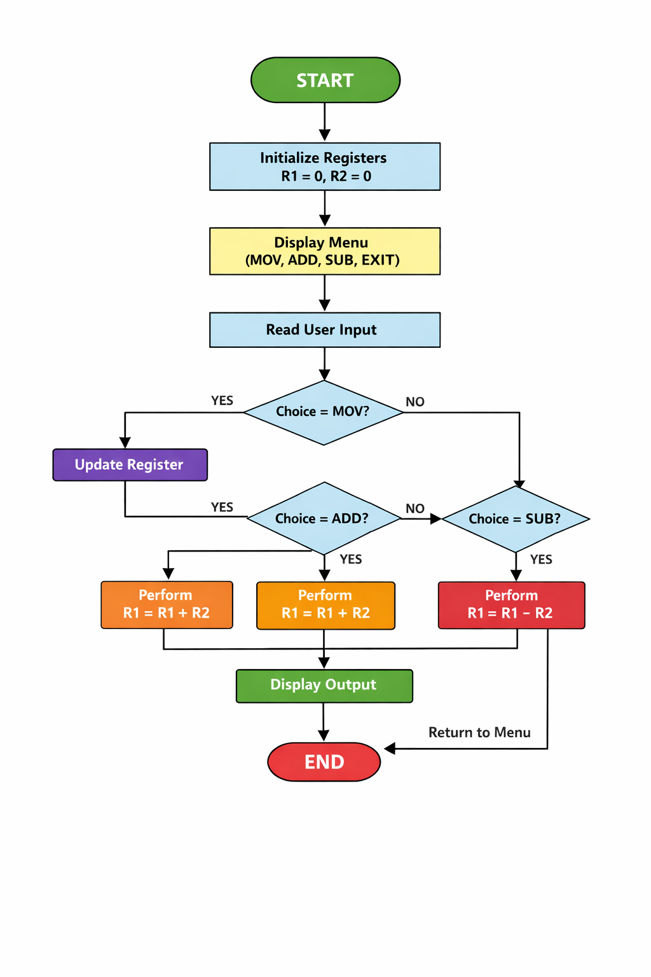

8. Implementation Logic (Algorithm)
- Start program
- Initialize register values
- Display instruction menu
- Accept user input
- Use switch-case to process instruction
- Perform arithmetic or data movement operation
- Update register values
- Display updated register state
- Repeat until exit command
- Terminate program

9. Core Implementation (Sample Code)
#include <stdio.h>
int stack[100];
int sp = -1; // stack pointer
int memory[200];
int R[8]; // 4 Registers
int pc = 0;
int running = 1;
int ZF = 0; // Zero Flag
int NF = 0; // Negative Flag
void updateFlags(int result) {
ZF = (result == 0);
NF = (result < 0);
}
void execute() {
while (running) {

int opcode = memory[pc];
int op1 = memory[pc + 1];
int op2 = memory[pc + 2];
case 1: // LOAD
R[op1] = op2;
updateFlags(R[op1]);
pc += 3;
break;
case 2: // ADD
R[op1] = R[op1] + R[op2];
updateFlags(R[op1]);
pc += 3;
break;
case 3: // SUB
R[op1] = R[op1] - R[op2];
updateFlags(R[op1]);
pc += 3;
break;
case 4: // MUL
R[op1] = R[op1] * R[op2];
updateFlags(R[op1]);
pc += 3;
break;
case 5: // DIV
if (R[op2] != 0) {
R[op1] = R[op1] / R[op2];
updateFlags(R[op1]);
}
pc += 3;
break;
case 6: // PRINT
printf("R%d = %d\n", op1, R[op1]);
pc += 3;
break;
case 7: // AND
R[op1] = R[op1] & R[op2];
updateFlags(R[op1]);
pc += 3;
break;
case 8: // OR
R[op1] = R[op1] | R[op2];
updateFlags(R[op1]);
pc += 3;
break;
case 9: // XOR
R[op1] = R[op1] ^ R[op2];
updateFlags(R[op1]);
pc += 3;
break;
case 10: // NOT
R[op1] = ~R[op1];
updateFlags(R[op1]);
pc += 3;
break;
case 11: // CMP
updateFlags(R[op1] - R[op2]);
pc += 3;
break;
case 12: // JMP
pc = op1;
break;
case 13: // JZ
if (ZF)
pc = op1;
else
pc += 3;
break;
case 14: // STORE
memory[op2] = R[op1];
pc += 3;
break;
case 15: // LOADM
R[op1] = memory[op2];
pc += 3;
break;
case 16: // PUSH
stack[++sp] = R[op1];
pc += 3;
break;
case 18: // CALL
stack[++sp] = pc + 3; // save return address
pc = op1;
break;
case 19: // RET
pc = stack[sp--];
break;
case 0: // HALT
running = 0;
break;
default:
printf("Invalid Instruction\n");
running = 0;
}
}
}
int main() {
int choice;
int num1, num2;
while(1) {
printf("\n===== MINI CPU MENU =====\n");
printf("1. Factorial\n");
printf("2. Square\n");
printf("3. Addition\n");
printf("4. Subtraction\n");
printf("5. Multiplication\n");
printf("6. Division\n");
printf("7. AND\n");
printf("8. OR\n");
printf("9. XOR\n");
printf("0. Exit\n");
printf("Enter choice: ");
scanf("%d", &choice);
if(choice == 0) {
printf("Shutting down CPU...\n");
break;
}
// Reset CPU state
pc = 0;
running = 1;
for(int i=0;i<4;i++) R[i]=0;
for(int i=0;i<200;i++) memory[i]=0;
if(choice == 1) {
printf("Enter number: ");
scanf("%d", &num1);
// Factorial
memory[0]=1; memory[1]=1; memory[2]=1; // R1 = 1
memory[3]=1; memory[4]=2; memory[5]=num1; // R2 = num
memory[6]=1; memory[7]=3; memory[8]=1; // R3 = 1
int loop = 9;
memory[9]=4; memory[10]=1; memory[11]=2; // MUL
memory[12]=3; memory[13]=2; memory[14]=3; // SUB
memory[15]=11; memory[16]=2; memory[17]=3; // CMP
memory[18]=13; memory[19]=24; memory[20]=0; // JZ END
memory[21]=12; memory[22]=loop; memory[23]=0; // JMP LOOP
memory[24]=6; memory[25]=1; memory[26]=0; // PRINT
memory[27]=0;
}
else if(choice >=2 && choice <=9) {
printf("Enter first number: ");
scanf("%d", &num1);
printf("Enter second number: ");
scanf("%d", &num2);
memory[0]=1; memory[1]=0; memory[2]=num1;
memory[3]=1; memory[4]=1; memory[5]=num2;
int opcode;
switch(choice) {
case 2: opcode = 4; break; // Square handled below
case 3: opcode = 2; break; // ADD
case 4: opcode = 3; break; // SUB
case 5: opcode = 4; break; // MUL
case 6: opcode = 5; break; // DIV
case 7: opcode = 7; break; // AND
case 8: opcode = 8; break; // OR
case 9: opcode = 9; break; // XOR
}
if(choice == 2) {
// Square
memory[3]=4; memory[4]=0; memory[5]=0;
memory[6]=6; memory[7]=0; memory[8]=0;
memory[9]=0;
} else {
memory[6]=opcode; memory[7]=0; memory[8]=1;
memory[9]=6; memory[10]=0; memory[11]=0;
memory[12]=0;
}
}
execute();
}
return 0;
}

10. Results
The Mini CPU Emulator successfully simulates instruction execution and register manipulation. The system performs arithmetic and data movement operations accurately, reflecting expected processor behavior in a simplified environment.

11. Applications
- Academic demonstration of CPU architecture
- Foundation for building advanced emulators
- Embedded systems education
- Introductory processor design simulation
- Training tool for understanding low-level computation

12. Future Enhancements
To improve scalability and realism, the following features can be added:
- Memory array simulation
- Program Counter (PC) implementation
- Instruction Register (IR) simulation
- Support for additional instructions (MUL, DIV, AND, OR)
- File-based instruction execution
- Assembly-like instruction parsing
- GUI-based visualization

13. Conclusion
The Mini CPU Emulator demonstrates core processor concepts through structured programming in C. By abstracting hardware operations into software logic, the project bridges the gap between theoretical computer architecture and practical implementation. It provides a strong foundational model for further exploration into processor simulation and low-level system design.

